Alfreton Park Reading Spine Cycle 2 – 2026-2027
The long-term plan below shows the high-quality texts studied at Alfreton Park which enhance and support our new AP curriculum. These texts have been carefully selected by our teaching experts to ensure children experience a range of quality children’s books as part of whole class teaching. The Power of Reading puts quality children’s literature at the heart of literacy learning and is built on years of research and best practice. A wide range of Power of Reading teaching sequences are fostered and delivered to support effective teaching across all pathways.
Pathway | Autumn 1 | Autumn 2 | Spring 1 | Spring 2 | Summer 1 | Summer 2
Secondary – Formal | 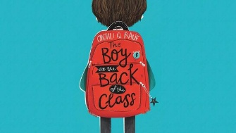  The Boy at the Back of the Class  Onjali Q Raúf | 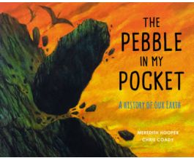  Pebble in My Pocket  Meredith Hooper and Chris Coady | 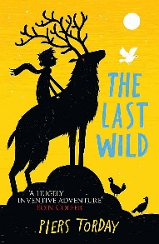  The Last Wolf  Piers Torday | 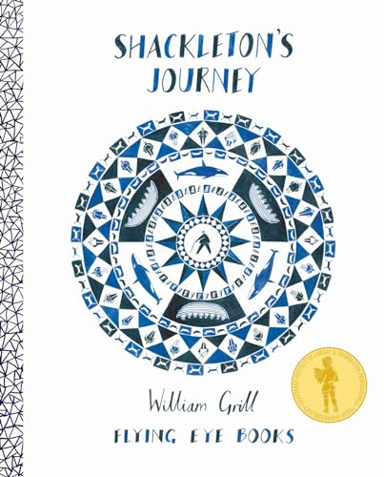  Shackleton’s Journey  William Grill | 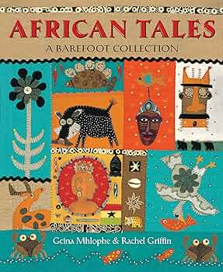  African Tales  Gcina Mhlophe | 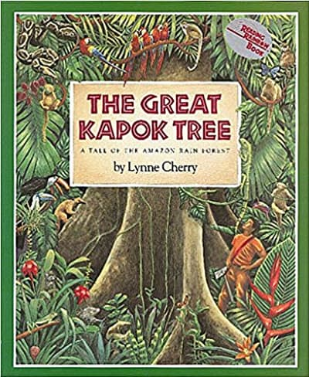  The Great Kapok Tree  Lynne Cherry
Primary – Formal | 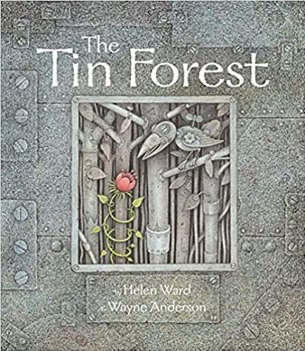  The Tin Forest  Helen Ward and Wayne Anderson | 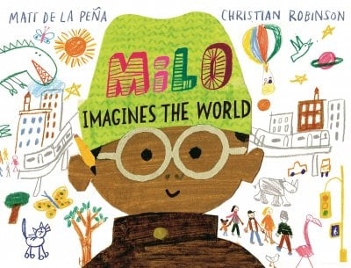  Milo Imagines the World  Matt de la Peña and Christian Robinson | 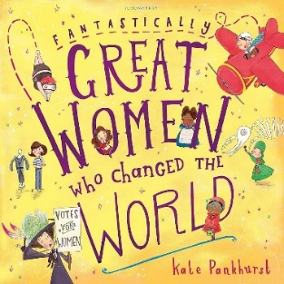  Great Women who Changed the World  Kate Pankhurst | 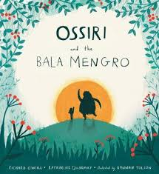  Ossiri and the Bala Mengro  Richard O’Neill and Katherine Quarmby | 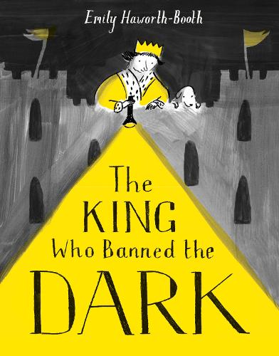  The King who Banned the Dark  Emily Haworth-Booth | 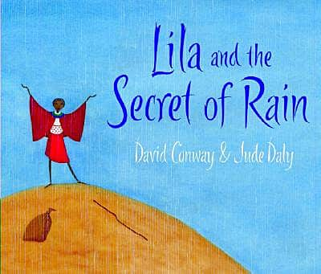  Lila and the Secret of Rain  Alexis Deacon
Semi-formal | 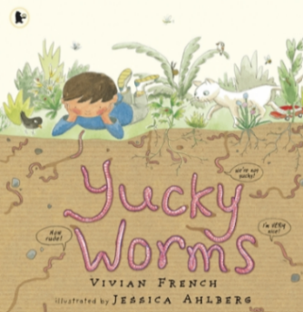  Yukky Worms  Jessica Ahlberg | 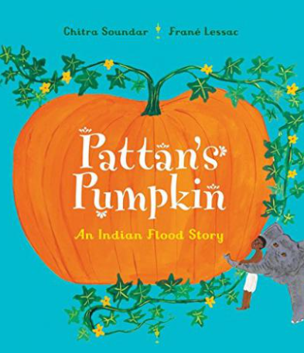  Pattan’s Pumpkin  Chitra Soundar | 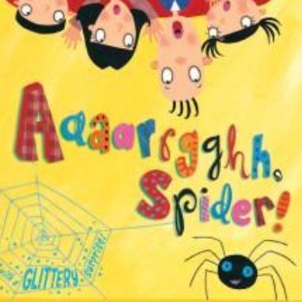  Aaaaaaargh, Spider!  Lydia Monks | 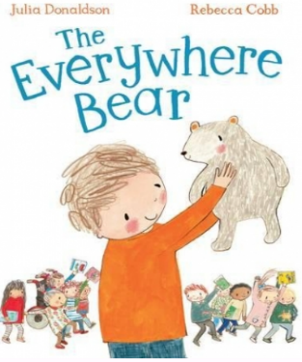  The Everywhere Bear  Julia Donaldson | 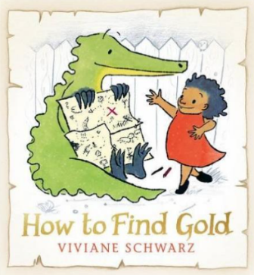  How to Find Gold  Viviane Schwarz | 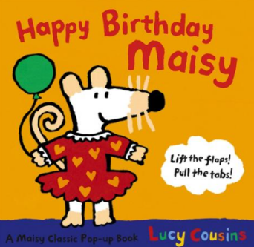  Happy Birthday, Maisy  Lucy Cousins
Informal | 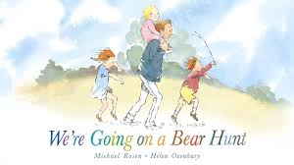  We’re Going on a Bear Hunt  Michael Rosen | 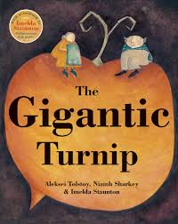  The Gigantic Turnip  Aleksei Tolstoy | 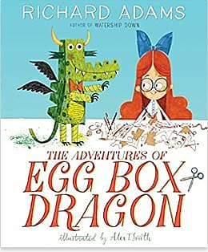 The Adventures of the Egg Box Dragon!  Ricard Adams | 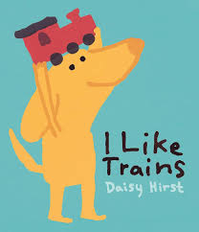  I like Trains  Daisy Hurst | 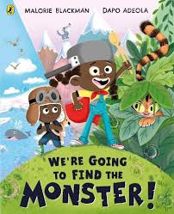  We’re Going to Find a Monster  Malorie Blackman | 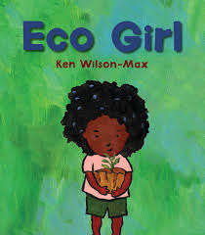  Eco Girl  Ken Wilson-Max
Pre-formal | 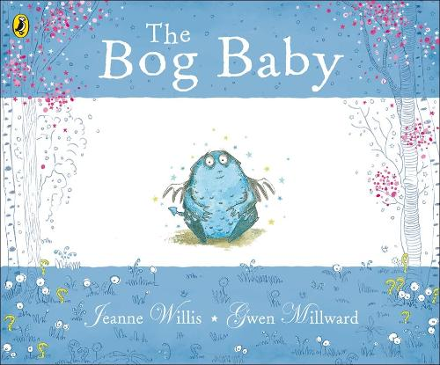 | 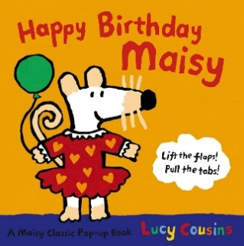  Happy Birthday, Maisy  Lucy Cousins | 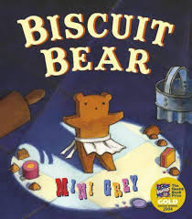 | 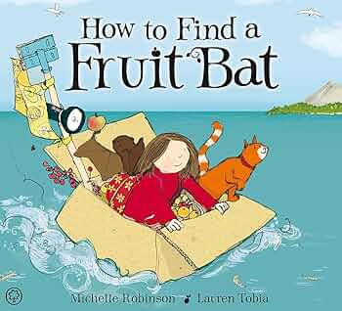 | 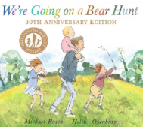  We’re Going on a Bear Hunt  Michael Rosen | 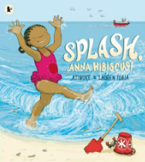
EYFS |  | Happy Birthday, Maisy  Lucy Cousins |  |  | We’re Going on a Bear Hunt  Michael Rosen

